Megatrends: Data Across Disciplines

Heat Maps
Efficient visualizations of dense data sets
NF | NF | RP | RP | F
OA | OA | EE | EE | EE
NBT | NBT | NS | NS | NS
MD | MD | SP | SP | SP
G | G | G | G | G

Data Story: Math
Provide your teachers and administrators a compelling narrative
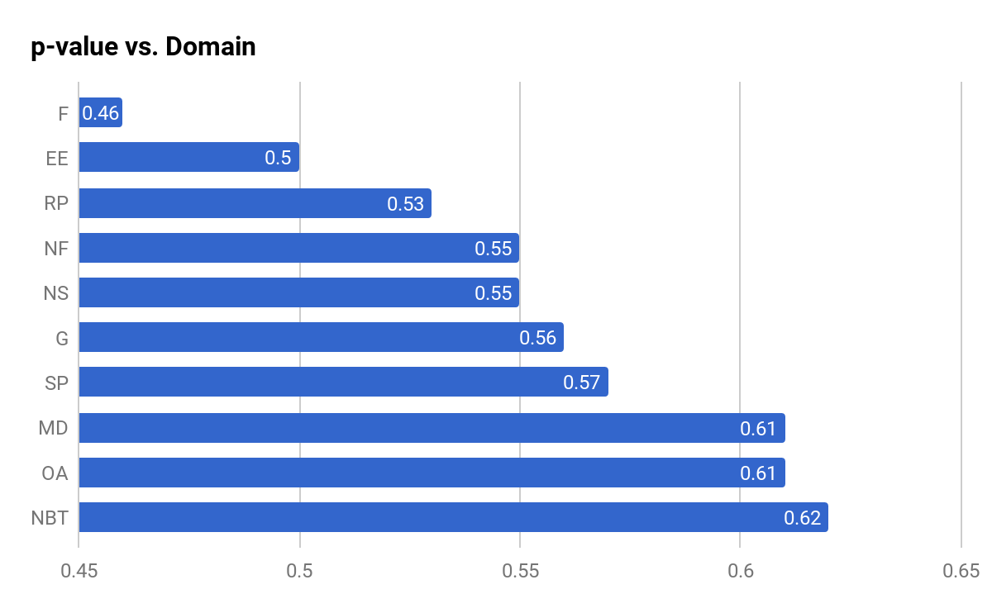

Data Story: Megatrends
Give teams across grades and disciplines a frame for conversation
 | Grade 3 | Grade 4 | Grade 5 | Grade 6 | Grade 7 | Grade 8
Overall Literature Scores | .53 | .57 | .57 | .59 | .57 | .64
Refer to details in text (X.1) | .58 | .60 | .56 | .60 | .63 | .66
ID theme (X.2) | .50 | .59 | .56 | .59 | .55 | .64

Slide Deck: Less Is More
Adjust your storytelling to your audience and setting
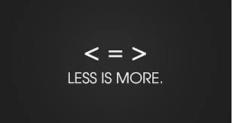

Contact Information
Let’s continue the conversation!
@gadfly1974
andrew.mitchell@wflboces.org

